BUCPS ANNUAL GENERAL MEETING
Monday, September 25, 2023
ONLINE ZOOM
MEETING MINUTES

In Attendance:
Slavko Nohas Kelsey Whattam Natalia Kostiuk Clayton Starko
Christin Hyshka Peter Rachmistruk Pierre Oimet Oleksandr Pravdyvi
Andrea Chmilar Dustin Maloney Talia Koziak

Proceedings:
- Slavko opened the meeting with a prayer at 7:05pm.
- Slavko welcomed all to the meeting and thanked everyone for attending. Brief introductions were made.

Amendments and Approval of Agenda
- Agenda reviewed. Copies of the agenda were forwarded via email prior to the meeting.
  - Andrea Chmilar will add item C in Financial Report for Sadochok accounts, going forward.
  - Motion: Thalia Koziak moved that the agenda be approved. Seconded by Andrea Chmilar. All in favour. None opposed. Motion carried.

Election of AGM Chair and AGM Secretary
- Motion: Andrea Chmilar moved that Peter Rachmistruk chair the meeting. Seconded by Christin Hyshka. All in favour. None opposed. Motion carried.
- Motion: Andrea Chmilar moved that Kelsey Whattam take the meeting’s minutes. Seconded by Christin Hyshka. All in favour. None opposed. Motion carried.

Amendments and Approval of Minutes
- Minutes from the last AGM, held October 4, 2022 were forwarded via email prior to the meeting for review.
  - Motion: Andrea Chmilar moves to amend the correct spelling of Jackie Fedoriuk. Thalia Koziak seconded. All in favour. None opposed. Motion carried.

Business Arising from the Minutes:
- None.

Financial Report:
- See attached report, as presented by Andrea Chmilar.
- Motion: Andrea Chmilar moves the financial report as presented. Jackie Fedoriuk and Shelley Tyrkalo audited as Clayton Starko was unable to. Kelsey Whattam seconds. All in favour. None opposed. Motion carried.
- Christin Hyshka questioned Larisa Sembaliuk Cheladyn print, framing costs. Every year, this is a large expense we inquire and is this sustainable?
  - Andrea Chmilar stated the past two years have been an exception as the class sizes have been quite large and likely will not see this again until the kindergarten year of 2022/20223 reaches those monumental celebration years.
  - The 4-8-12 celebration currently does not entail a dinner, so the prints are a nice tradition to honour students and family.
  - Slavko Nohas suggested this be tables for a regular meeting so we are able to discuss better use of funds.
- Appointment of Auditors for the 2023-2024 Financial Statements review – Clayton Starko and Jackie Fedoriuk to review our financial statements.
  - Motion: Andrea Chmilar moves that her report be accepted as presented. Seconded by Talia Koziak. All in favour. None opposed. Motion carried.

- Sadochok Financial
  - Motion: Andrea Chmilar suggests Sadochok Financials be presented via BUCPS as the are apart of the corporate registry and Sadochok is simply not large enough. Christin Hyshka seconds. All in favour. None opposed. Carried.

- Signing Authority
  - Motion: Andrea Chmilar motions the signing authorities for the Casino, General and Sadochok account should include President, Vice President, Treasurer and Secretary. Christin Hyshka seconds. All in favour. None opposed. Carried.

- Andrea Chmilar wanted to note the grants BUCPS received from UBLA and SUBA. Without their support, our program would not be able to provide some of the cultural opportunities for our students and we are very thankful to have these organizations.

President’s Report:
- See attached report, as presented by Slavko Nohas.
  - Motion: Slavko Nohas moved that his report be accepted as presented. Seconded by Andrea Chmilar. All in favour. None opposed. Motion carried.

Election of Officers:
Slate for 2023-2024 BUCPS Executive is proposed as follows:
President – Slavko Nohas
Vice President – Christin Hyshka
Treasurer – Andrea Chmilar
Secretary – Kelsey Whattam
Fundraising Coordinators –
Members at Large – Talia Koziak, Kathy Leskow, Clayton Starko

Motion: Peter Rachmistruk motions for all Execuive positions be slated as presented. Dustin Maloney seconds. All in favour. None Opposed. Carried.

Adjournment:
- Motion: Andrea Chmilar motions to adjourn the AGM meeting at 8:17pm. Christin Hyshka seconds. All in favour. None opposed. Carried.
- Meeting minutes recorded by Kelsey Whattam.

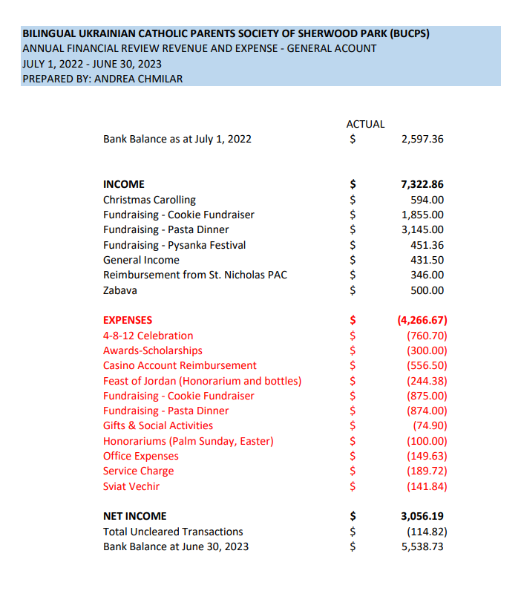

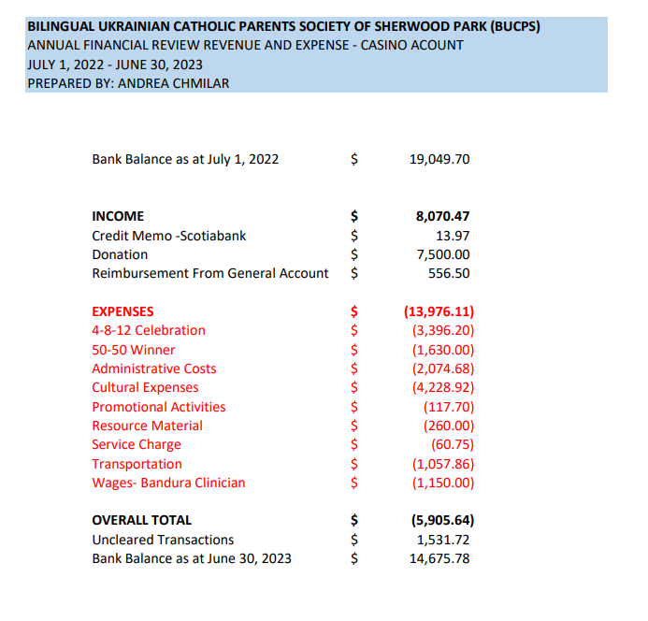

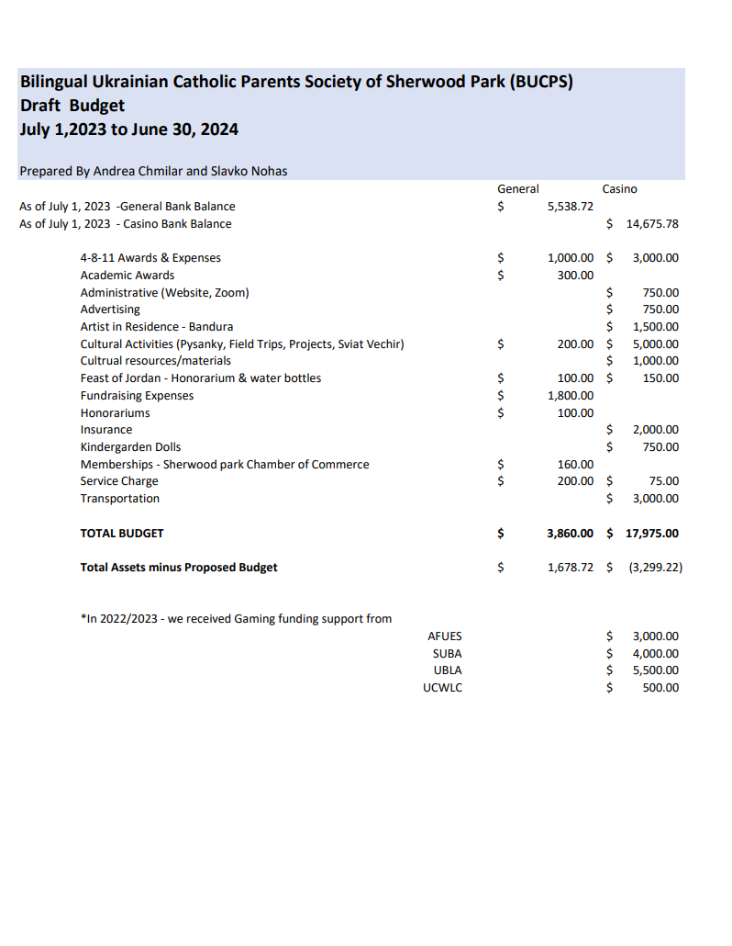
BUCPS President Report
September 25, 2023
Thank you for attending the AGM. In 2022-23, students once again participated in field trips, in class learning and social gatherings in our community.

Дякуємо за участь у загальних зборах. В минулому році cтуденти знову брали участь в екскурсіях, навчанні в класі та в громадських зустрічах.

A few BUCPS highlights from the past year:
- Little Orchard Sadochok – Pani Sombyk
- First Pasta Fundraiser
- St. Nicholas visited our students and brought well wishes for the Christmas season
- Christmas Cookie Fundraiser – thank you to Kathy Leskow and Confetti Sweets
- Students from ABJ and some parents, provided “Koliada” for BUCPS families
- Volunteers worked the BUCPS booth at UFest in Edmonton
- 4-8-12 Celebration occurred on June 11th where we came together as a community to honour our students moving into the next phase of their educational journey
- BUCPS volunteers sold 50/50 tickets at the Vegreville Pysanka Festival in July – community involvement is important

Overall, these highlights and activities began to once again stress the importance of faith, community and tradition. Our Ukrainian culture is rich and powerful and we have an opportunity to share this with our children and our community.

Я вітаю всіх наших новоприбулих з України до нашій спільноти. We continue to support and welcome families to our area and our schools fleeing the unprovoked war in Ukraine. I welcome all of our newcomers from Ukraine into our Sherwood Park community.

I would like to thank the executive members that served in the past year. Christin Hyshka, VP; Andrea Chmilar, Treasurer; Kelsey Whattam, Secretary. Also thank you to our MAL Talia Koziak, Kathy Leskow and Clayton Starko. Thank you for your hard work and dedication to our society and to the Ukrainian Bilingual Program in Sherwood Park.

To our teachers, administrators and all those working diligently in our schools, thank you. Your efforts are tireless and your commitment to providing our children a well rounded education does not go un noticed. BUCPS looks forward to a continued relationship for many years to come.

Thank you to SUBA, AFUSE, UCWLC and UBLA for providing additional funding to BUCPS through their casino funds.

Moving forward, we need to ensure that our Ukrainian bilingual program continues to grow. The Little Orchard Sadochok is once again up and running after a successful year. Now we need to work in order to keep children in our bilingual program from K-12. I am proud of our program, proud of our community and proud to be president of this society.
May God bless. Нехай Бог Благословить

Respectfully Submitted September 25 2023, Slavko Nohas, President

